

**Green University of Bangladesh**

**Department of Computer Science and Engineering (CSE)**

**Faculty of Sciences and Engineering**

**Semester: (Summer, Year: 2021), B.Sc. in CSE (Day)**

**Course Title: Structured Programming Lab**

**Course Code: CSE 104 Section: 213 DD**

**Lab Project Name: Phonebook management system**

**Student Details**

|  |  |  |
| --- | --- | --- |
| **Name** | | **ID** |
| **1.** | Rabiul Hasan | 213902072 |

**Submission Date: _ _ _30-04-2022 _ _ _ _ _ _ _ _ _ _ _ _ _ _ _ _ _ _ _ _ _**

**Course Teacher’s Name: _MD. Sultanul Islam Ovi _ _ _ _ _ _ _ _ _ _ _ _ _ _ _ _ _ _ _ _ _ _ _**

**[For Teachers use only: Don’t Write Anything inside this box]**

|  |
| --- |
| **Lab Project Status**  **Marks: ………………………………… Signature: .....................**  **Comments: .............................................. Date: ..............................** |

Table of Contents

**Chapter 1 Introduction** 1

1.1 Introduction 3

1.2 Design Goals/Objective 5

**Chapter 2** 6

**Implementation of the Project** **7**

2.2 Implementations 8

2.3 Screenshots 9

**Chapter 3 Conclusion** **10**

3.1 Learning Outcome 12

3.2 Future Scope 13

**References** **14**

# Chapter 1 Introduction

## Introduction

The phonebook is a very simple C (oop) mini-project that can help you understand the basic concepts of functions, file handling, and data structure. This program will teach you how to add, list, change or edit, search and remove data from/to a file. Adding new records, listing them, editing and updating them, looking for saved contacts, and removing phonebook records are simple Functions that make up the main menu of this Phonebook program.

Personal information, such as name, gender, phone number, e-mail, and address, is requested when you add a record to your phonebook. These records can then be updated, entered, searched, and deleted. I’ve used a lot of functions in this mini-project. These functions are easy to understand since their name means just their respective operations.

## Design Goals/Objective

The goal of the project is to design an phonebook Management system :

Create a “Contact Phonebook” framework using C programming. This software is very useful nowadays to store full information under a single contact number. The software also has options for removing and changing the contact number entered

# Chapter 2

# Implementation of the Project

**Designing modules of phonebook Management System**

The software architecture consists of the following modules: Preprocessor commands, Functions, Variables, Statements & Expressions.

**Module -1: (Header files)**

* #include<stdio.h>
* #include<conio.h>
* #include<string.h>
* #include<stdlib.h>
* #include<windows.h>

**Module-2:(declaring functions):**

This function displays the user to select his choice of operations.

**Module-3(main function):**

A function declared in a class named phone book in a program.

**Module -4(adding menu):**

This module is used for inputting menu details.

**Module-5(list record**):

This part is to show up the saved contacts list.

**Module -6 (searching ra ecord) :**

This method requires the user to assign a name to the contact number of the contact being checked.

**Module-7 (Deleting a record) :**

This choice deletes a person’s added contact information.

**Module-8 (Modifying a record) :**

This choice is used to update or alter the information of the record.

1. **Implementation**

C source code

**#include<stdio.h>**

**#include<conio.h>**

**#include<string.h>**

**#include<stdlib.h>**

**#include<windows.h>**

**struct person**

**{**

**char name[35];**

**char address[50];**

**char father_name[35];**

**char mother_name[30];**

**long int mble_no;**

**char sex[8];**

**char mail[100];**

**char citision_no[20];**

**};**

**void menu();**

**void got();**

**void start();**

**void back();**

**void addrecord();**

**void listrecord();**

**void modifyrecord();**

**void deleterecord();**

**void searchrecord();**

**int main()**

**{**

**system("color 5f");**

**start();**

**return 0;**

**}**

**void back()**

**{**

**start();**

**}**

**void start()**

**{**

**menu();**

**}**

**void menu()**

**{**

**system("cls");**

**printf("\t\t**********WELCOME TO PHONEBOOK*************");**

**printf("\n\n\t\t\t MENU\t\t\n\n");**

**printf("\t1.Add New \t2.List \t3.Exit \n\t4.Modify \t5.Search\t6.Delete");**

**switch(getch())**

**{**

**case '1':**

**addrecord();**

**break;**

**case '2': listrecord();**

**break;**

**case '3': exit(0);**

**break;**

**case '4': modifyrecord();**

**break;**

**case '5': searchrecord();**

**break;**

**case '6': deleterecord();**

**break;**

**default:**

**system("cls");**

**printf("\nEnter 1 to 6 only");**

**printf("\n Enter any key");**

**getch();**

**menu();**

**}**

**}**

**void addrecord()**

**{**

**system("cls");**

**FILE *f;**

**struct person p;**

**f=fopen("project","ab+");**

**printf("\n Enter name: ");**

**got(p.name);**

**printf("\nEnter the address: ");**

**got(p.address);**

**printf("\nEnter father name: ");**

**got(p.father_name);**

**printf("\nEnter mother name: ");**

**got(p.mother_name);**

**printf("\nEnter phone no.:");**

**scanf("%ld",&p.mble_no);**

**printf("Enter sex:");**

**got(p.sex);**

**printf("\nEnter e-mail:");**

**got(p.mail);**

**printf("\nEnter citizen no:");**

**got(p.citision_no);**

**fwrite(&p,sizeof(p),1,f);**

**fflush(stdin);**

**printf("\nrecord saved");**

**fclose(f);**

**printf("\n\nEnter any key");**

**getch();**

**system("cls");**

**menu();**

**}**

**void listrecord()**

**{**

**struct person p;**

**FILE *f;**

**f=fopen("project","rb");**

**if(f==NULL)**

**{**

**printf("\nfile opening error in listing :");**

**exit(1);**

**}**

**while(fread(&p,sizeof(p),1,f)==1)**

**{**

**printf("\n\n\n YOUR RECORD IS\n\n ");**

**printf("\nName=%s\nAdress=%s\nFather name=%s\nMother name=%s\nMobile no=%ld\nSex=%s\nE-mail=%s\nCitizen no=%s",p.name,p.address,p.father_name,p.mother_name,p.mble_no,p.sex,p.mail,p.citision_no);**

**getch();**

**system("cls");**

**}**

**fclose(f);**

**printf("\n Enter any key");**

**getch();**

**system("cls");**

**menu();**

**}**

**void searchrecord()**

**{**

**struct person p;**

**FILE *f;**

**char name[100];**

**f=fopen("project","rb");**

**if(f==NULL)**

**{**

**printf("\n error in opening\a\a\a\a");**

**exit(1);**

**}**

**printf("\nEnter name of person to search\n");**

**got(name);**

**while(fread(&p,sizeof(p),1,f)==1)**

**{**

**if(strcmp(p.name,name)==0)**

**{**

**printf("\n\tDetail Information About %s",name);**

**printf("\nName:%s\naddress:%s\nFather name:%s\nMother name:%s\nMobile no:%ld\nsex:%s\nE-mail:%s\nCitision no:%s",p.name,p.address,p.father_name,p.mother_name,p.mble_no,p.sex,p.mail,p.citision_no);**

**}**

**else**

**printf("file not found");**

**}**

**fclose(f);**

**printf("\n Enter any key");**

**getch();**

**system("cls");**

**menu();**

**}**

**void deleterecord()**

**{**

**struct person p;**

**FILE *f,*ft;**

**int flag;**

**char name[100];**

**f=fopen("project","rb");**

**if(f==NULL)**

**{**

**printf("CONTACT'S DATA NOT ADDED YET.");**

**}**

**else**

**{**

**ft=fopen("temp","wb+");**

**if(ft==NULL)**

**printf("file opaning error");**

**else**

**{**

**printf("Enter CONTACT'S NAME:");**

**got(name);**

**fflush(stdin);**

**while(fread(&p,sizeof(p),1,f)==1)**

**{**

**if(strcmp(p.name,name)!=0)**

**fwrite(&p,sizeof(p),1,ft);**

**if(strcmp(p.name,name)==0)**

**flag=1;**

**}**

**fclose(f);**

**fclose(ft);**

**if(flag!=1)**

**{**

**printf("NO CONACT'S RECORD TO DELETE.");**

**remove("temp.txt");**

**}**

**else**

**{**

**remove("project");**

**rename("temp.txt","project");**

**printf("RECORD DELETED SUCCESSFULLY.");**

**}**

**}**

**}**

**printf("\n Enter any key");**

**getch();**

**system("cls");**

**menu();**

**}**

**void modifyrecord()**

**{**

**int c;**

**FILE *f;**

**int flag=0;**

**struct person p,s;**

**char name[50];**

**f=fopen("project","rb+");**

**if(f==NULL)**

**{**

**printf("CONTACT'S DATA NOT ADDED YET.");**

**exit(1);**

**}**

**else**

**{**

**system("cls");**

**printf("\nEnter CONTACT'S NAME TO MODIFY:\n");**

**got(name);**

**while(fread(&p,sizeof(p),1,f)==1)**

**{**

**if(strcmp(name,p.name)==0)**

**{**

**printf("\n Enter name:");**

**got(s.name);**

**printf("\nEnter the address:");**

**got(s.address);**

**printf("\nEnter father name:");**

**got(s.father_name);**

**printf("\nEnter mother name:");**

**got(s.mother_name);**

**printf("\nEnter phone no:");**

**scanf("%ld",&s.mble_no);**

**printf("\nEnter sex:");**

**got(s.sex);**

**printf("\nEnter e-mail:");**

**got(s.mail);**

**printf("\nEnter citizen no\n");**

**got(s.citision_no);**

**fseek(f,-sizeof(p),SEEK_CUR);**

**fwrite(&s,sizeof(p),1,f);**

**flag=1;**

**break;**

**}**

**fflush(stdin);**

**}**

**if(flag==1)**

**{**

**printf("\n your data id modified");**

**}**

**else**

**{**

**printf(" \n data is not found");**

**}**

**fclose(f);**

**}**

**printf("\n Enter any key");**

**getch();**

**system("cls");**

**menu();**

**}**

**void got(char *name)**

**{**

**int i=0,j;**

**char c,ch;**

**do**

**{**

**c=getch();**

**if(c!=8&&c!=13)**

**{**

**\*(name+i)=c;**

**putch(c);**

**i++;**

**}**

**if(c==8)**

**{**

**if(i>0)**

**{**

**i--;**

**}**

**// printf("h");**

**system("cls");**

**for(j=0;j<i;j++)**

**{**

**ch=*(name+j);**

**putch(ch);**

**}**

**}**

**}while(c!=13);**

**\*(name+i)='\0';**

**}**

**Screenshots**

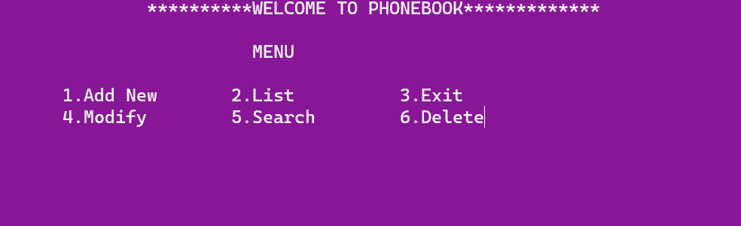

*Figure 3: Main Menu interface*

When the program is executed, the user will be directed to the main menu interface. The program is introduced with a few lines of texts. Then 6 selections are made for the user as the user can choose to Add new, List, Exit, Modify, Search and Delete the program.

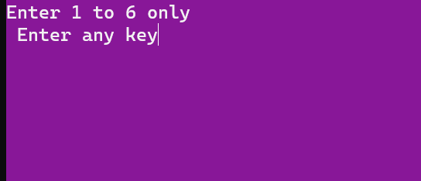

*Figure 4: Invalid value entered (main menu)*

. If the user accidentally enters an invalid input, an interface will be shown to notify the user to choose again and it notify the user again to enter from 1-6.

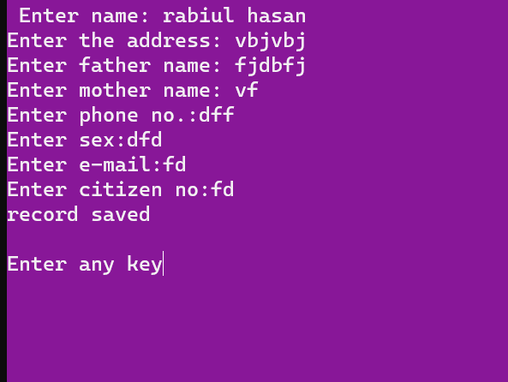

*Figure 5: Reservation function*

The program is asking the user to enter her/him information.

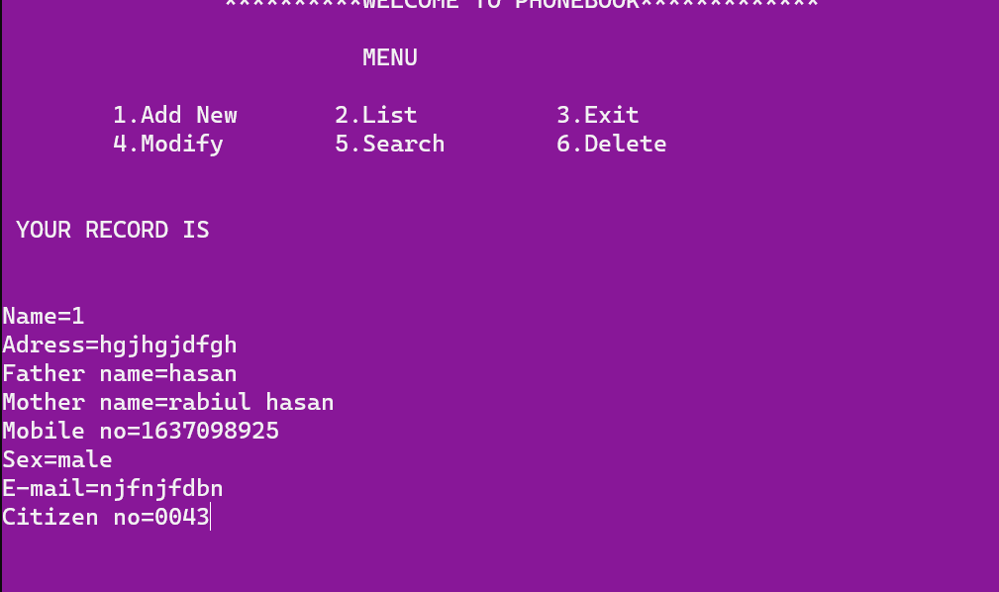

*Figure 6: the seat has successfully recorded*

As shown in the interface the seat information has been record successfully, after the user has entered the details.

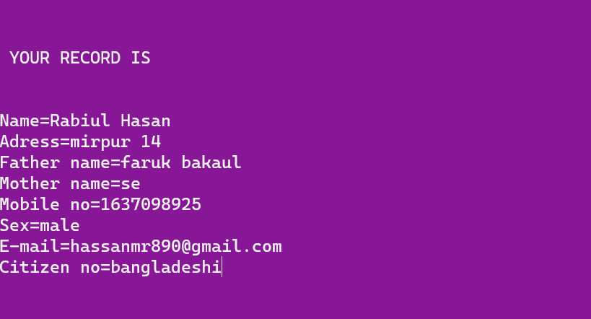

*Figure 7: search CONTACT’s name*

Search CONTACT’S name and find her/him information.

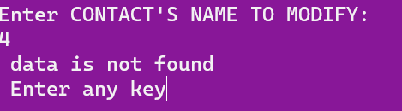

*Figure 8: CONTACT”S name invalid*

CONTACT”S name is not found beacouse name is invalid

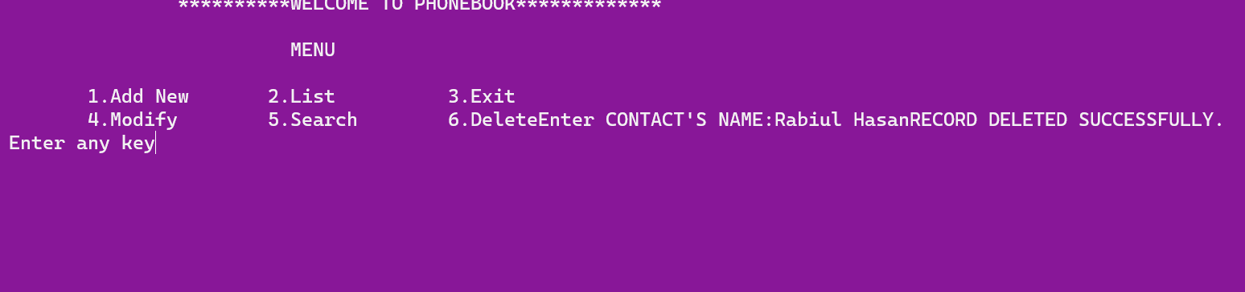

*Figure 10: Delete Rocord*

When enter 6 then all records deleted.

# Chapter 3 Conclusion

**Learning Outcome**

The Phone Book project is developing a program which deals with the combination ofstructures, arrays, File pointers and other functions. This program could do someoperations on arrays such as insertion, deletion, sorting, searching, update, retrieve,merging, append, exit.By implementing this program, we can execute the inserted contact data, deletion ofthe data, searching, updating, append, exit with numbers by using arrays and filepointers. This program is implemented for only numbers that can enter into an array.To do this analysis manually it takes a lot of time and patience but by implementingthis program using a high-level language like C it becomes much easier. But beforegoing to make final solution for the problem, the problem must be analysed.First of all, the basic information regarding the program which consists of complexnumbers. This program is solved by using several methods like one can solve thisprogram using user defined functions concept, loops conditions, go to statements. Inthis abstract we used the concept of functions, while loop, for loop, switch case and ifcondition’s which helps to execute the problem much easier. The following steps arefollowed while implementing the given program using if and while loop.The input is entered i.e., the value of choice (the menu no) select the particularmenu.Next it goes to particular menu and then go to the particular function.It prints the resultant value which came from the execution.The outcome of the work is one can get the required changes like inserting or deletingor sorting or merging or append or retrieve or update or exit for a given array.

**Future Scope**

* We can add every data to another person.
* We can also add information two or more person.

# References

* + - 1. Course hero [a learning site all about programmes].
      2. Code with c
      3. T4tutorial[learning website]